Ideation Phase
Define the Problem Statements
Template Screenshot:
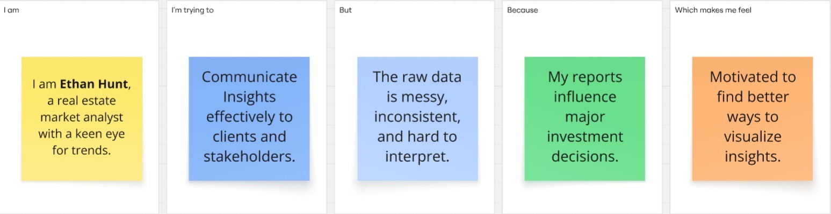
Problem Statemen  t | I am  (Customer) | I’m trying to | But | Because | Which makes me feel
PS-1 | Ethan Hunt | Communicate insights. | The raw data is messy. | My reports influence investment decisions. | Motivated
PS-2 | A realestate market analyst. | Understand housing market trends. | The raw data is inconsistent. | Clients rely on me for insights. | Frustrated

